2/11/2021

Saad Ahmed

Sidat hyder morshed associates

Data Extractor Utility

User Guide

Introduction:

The Data Extractor Utility is a desktop based application that is used to extract Pakistan Stock Exchange and Mutual Fund Association of Pakistan Website Data and used this data to view on the utility, store this data in database having database vendor (Microsoft / Oracle). Also this utility uses Pakistan Stock Exchange website data to view the Funds Profiles Market Summary.

Starting the Application:

Launch the application from the directory by double clicking on the icon highlighted in figure 1.

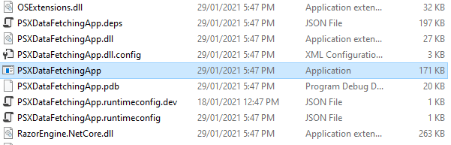

Figure

The first screen appears to you would be like figure 2.

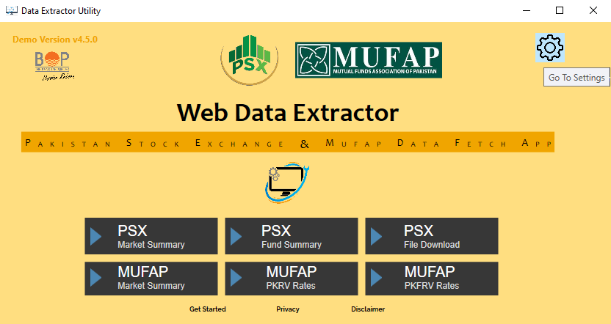

Figure

When you click on PSX Market Summary Button as highlighted in figure 3,

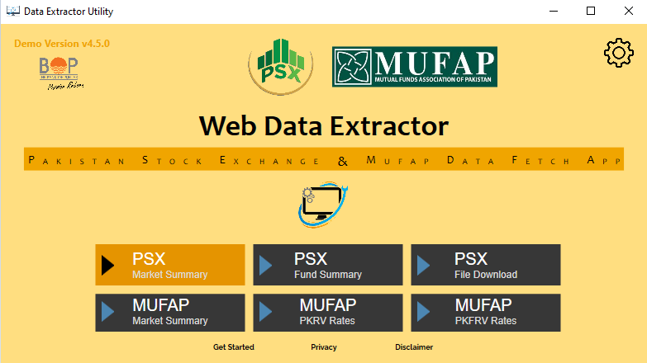

Figure

Pakistan Stock Exchange Market Summary Live Data Preview Screen will appear as shown in figure 4.

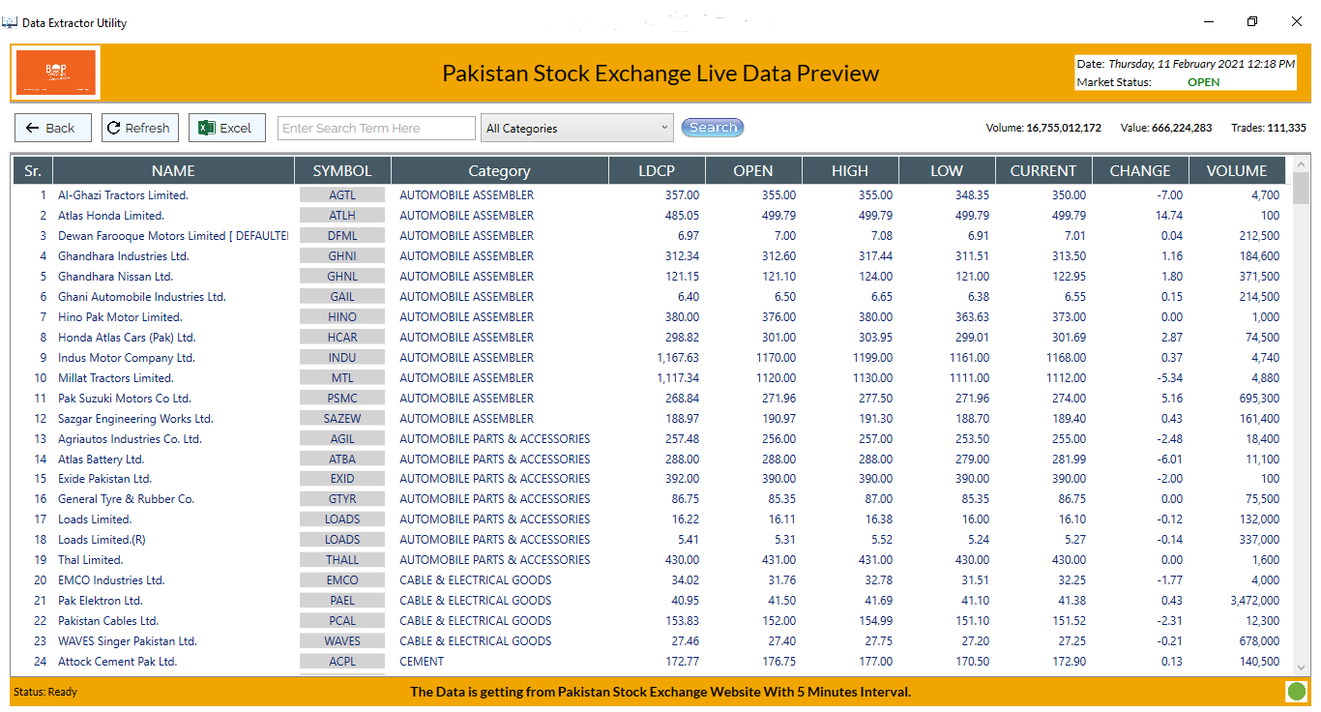

Figure

The data in Figure 4 is extracted from Pakistan Stock Exchange Website to filter the shares to a specific sector change the drop down selection as highlighted in figure 5.

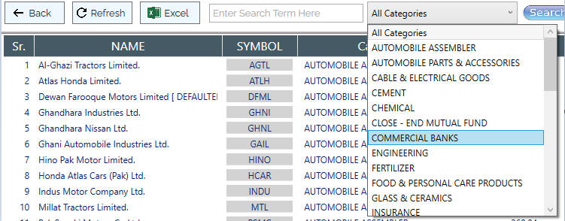

Figure

On Selecting Commertial Banks sector all the shares that belongs to commercial banks will appear as shown in figure 6.

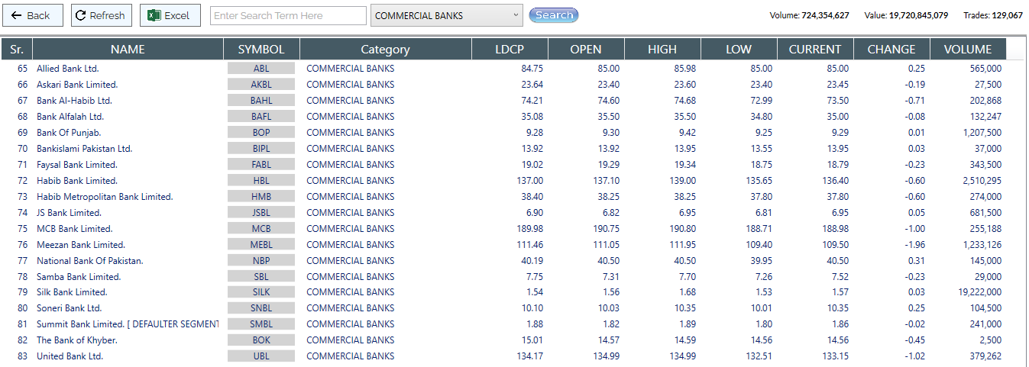

Figure

If you further want to filter data for a specific share you can type as highlighted in figure 7,



Figure

To export the data, you can click on Excel captioned button as shown in figure 8,

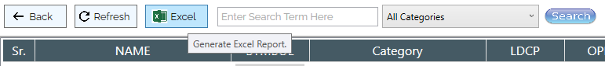

Figure

The preview will be in excel format as shown in figure 9.

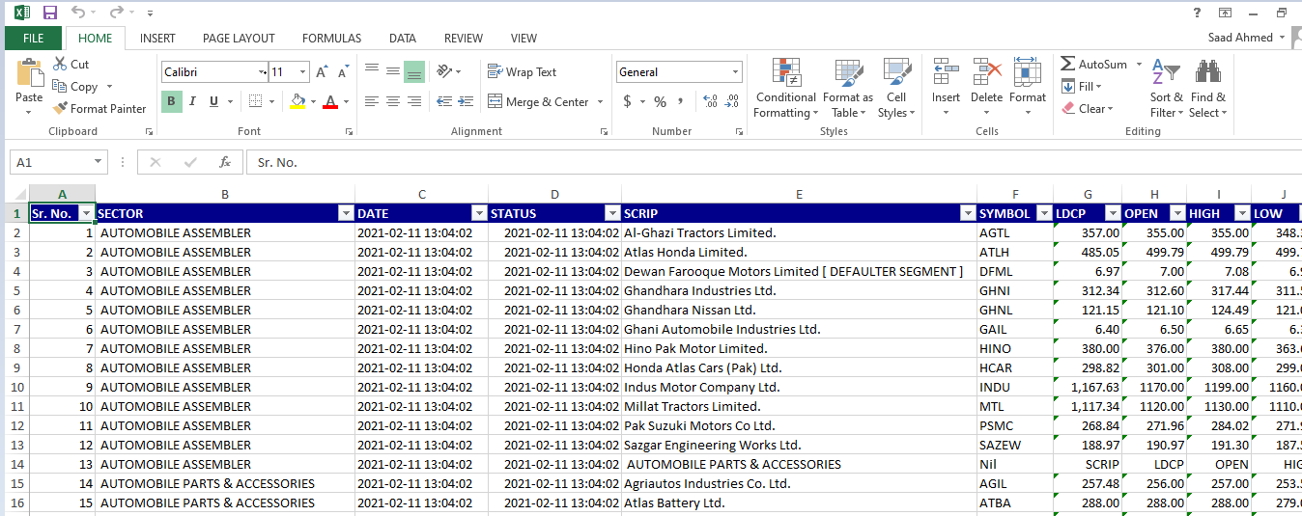

Figure

The Data in the dashboard will be auto update after a specific interval of time and when its updating the bottom line of the dashboard will let you know about its operation as shown in figure 10,

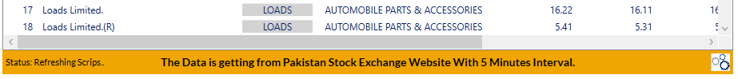

Figure

And when all operations are completed, the dashboard screen will appeared as shown in figure 11.



Figure

When you click on PSX Fund Summary Button as highlighted in figure 12,

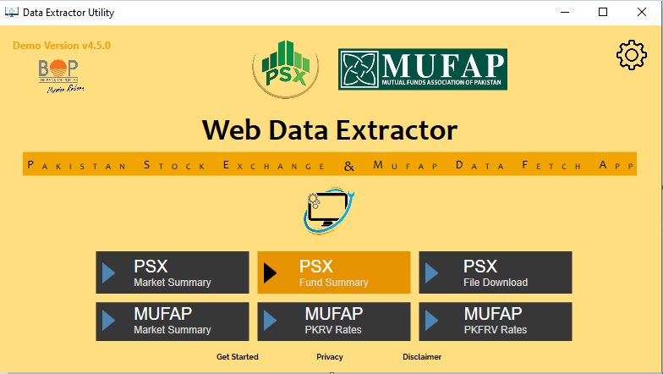

Figure

The Fund based Market Summary Dashboard will shows up as shown in figure 13,



Figure

To view shares market of specific fund select the fund highlighted in figure 14 and click on Go Button.

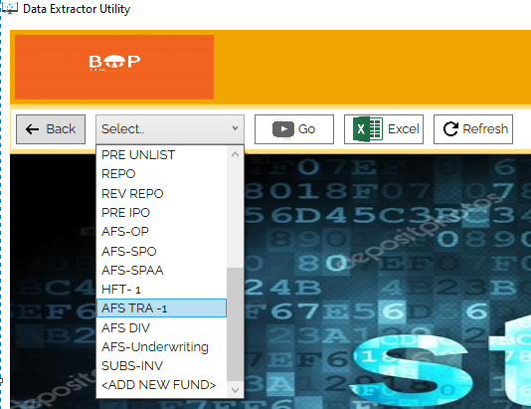

Figure

The list view will show the market current status as shown in figure 15.

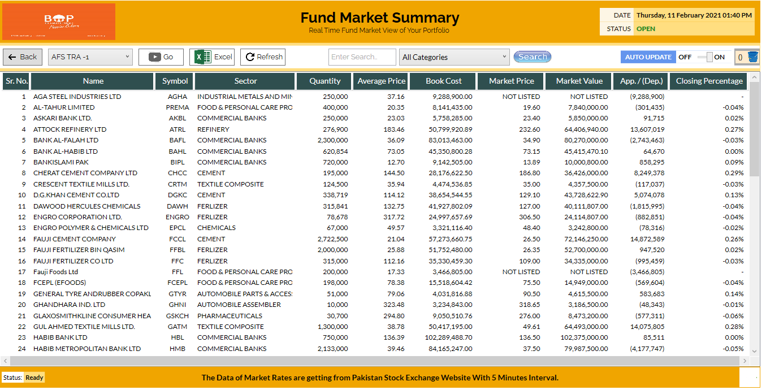

Figure

To find a specific scrip in the list enter the keyword in the textbox as shown in figure 16.

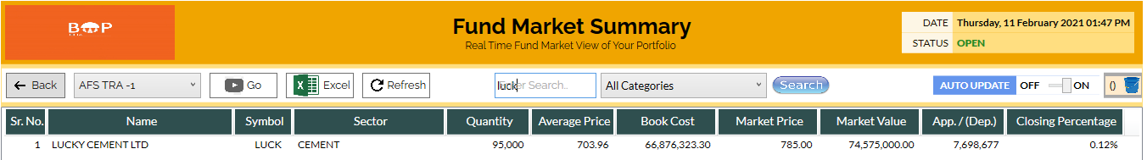

Figure

When you click on PSX File Upload Button as highlighted in figure 17,

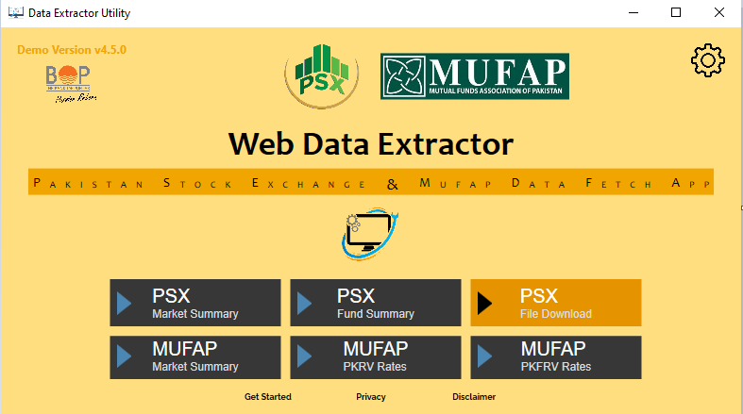

Figure

The screen similar to the figure 18 will appear,

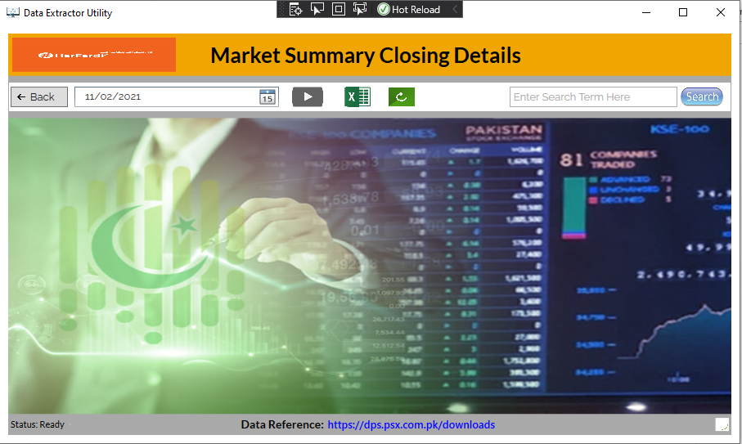

Figure

Select the date that contain the file you want to fetch as highlighted in figure 19,

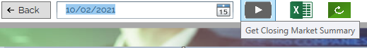

Figure

You can see the data as shown in figure 20

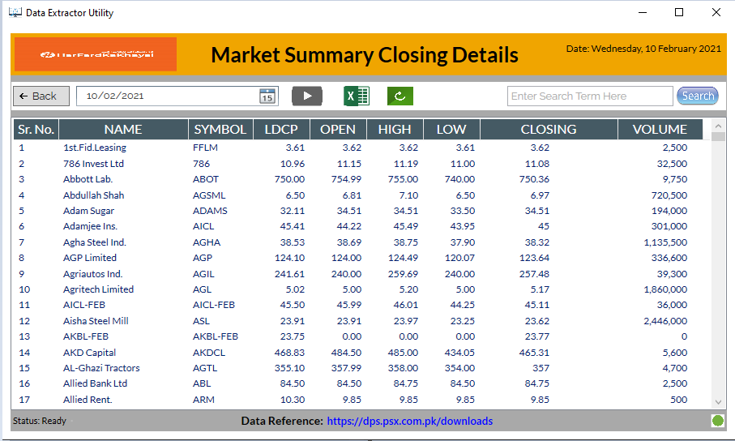

Figure

You can filter data from the search text box as shown in figure 21,

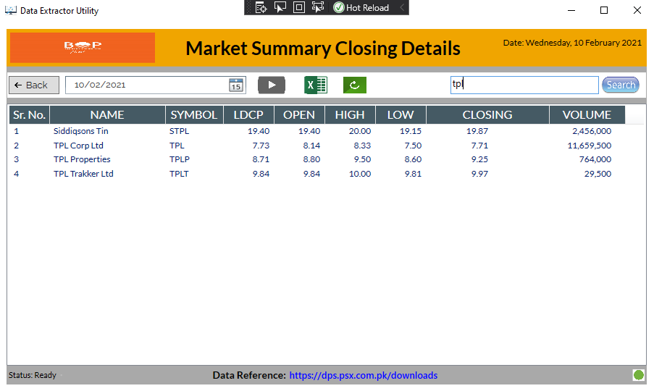

Figure

When you click on MUFAP Market Summary Button as highlighted in figure 22,

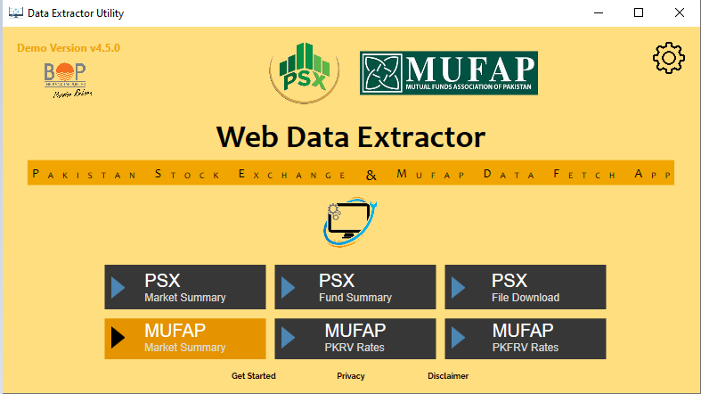

Figure

You can see the screen similar to figure 23

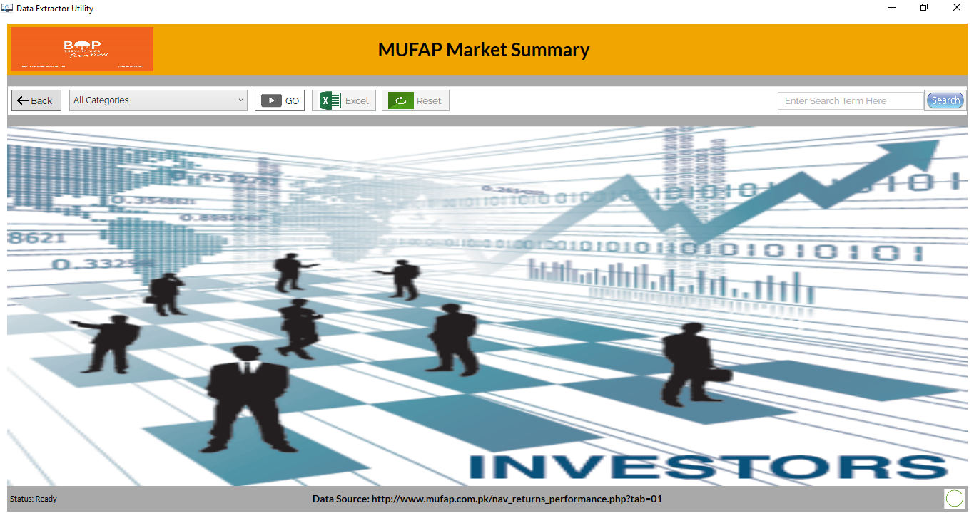

Figure

When you click on  button you can see the data as shown in figure 24

When you click on MUFAP Market Summary Button as highlighted in figure 25,

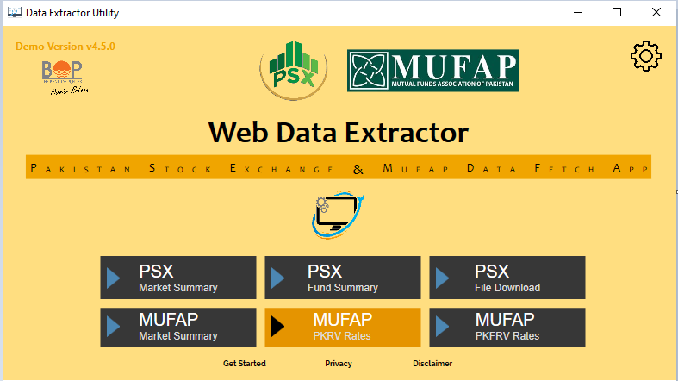

Figure 25

You can see the screen similar to figure 26

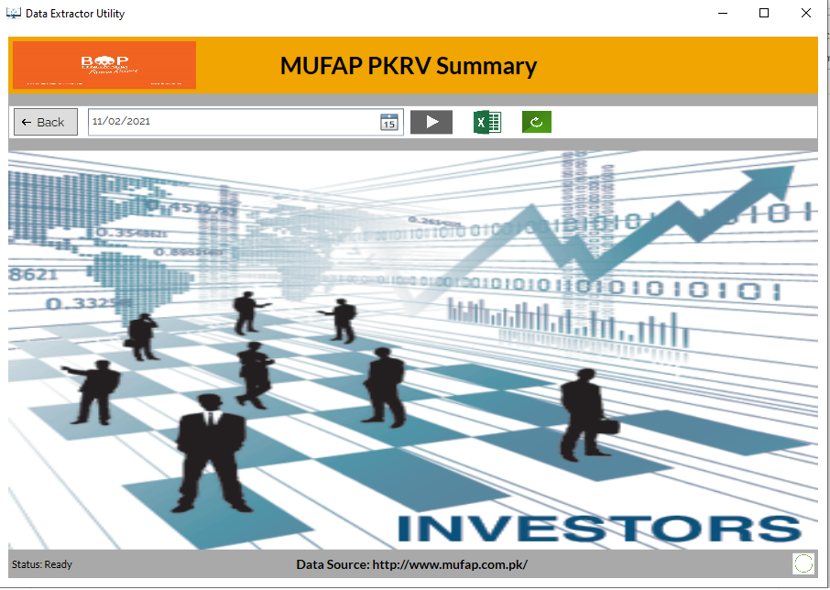

Figure 26

Select the date that contain the file you want to fetch as highlighted in figure 27,

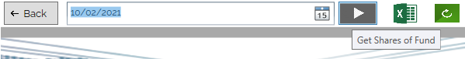

Figure 27

You can see data as shown in figure 28

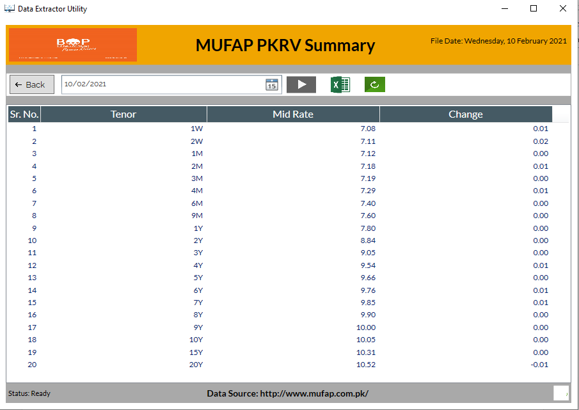

Figure 28

When you click on MUFAP Market Summary Button as highlighted in figure 29,

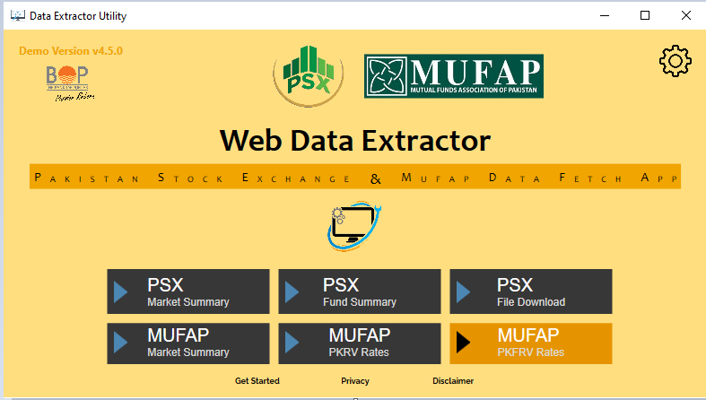

Figure 29

You can see the screen similar to figure 30,

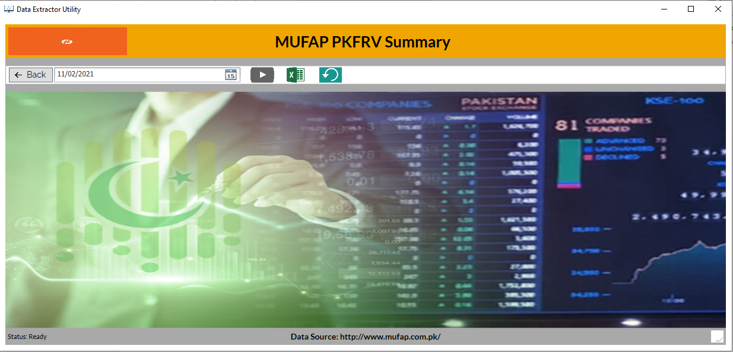

Figure 30

Select the date whose PKFRV value you want to fetch and click on the button as shown in figure 31,



Figure 31

You can see the data as shown in figure 32,

